Seal port Data Sheet

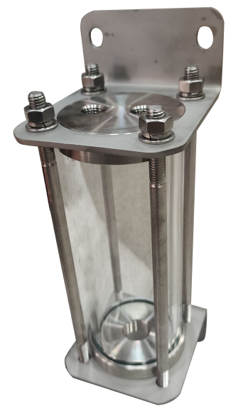

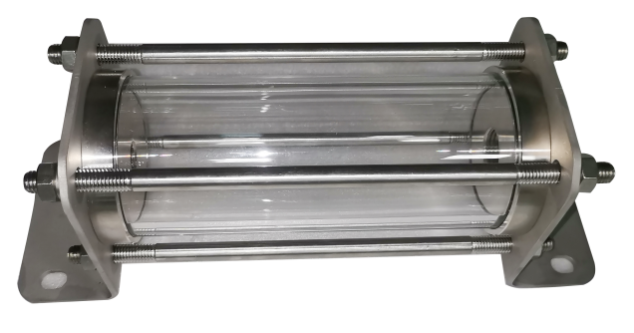
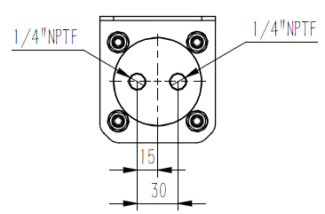

Item | Technical parameter
Model | SPB-200-SS | SPB-350-SS | SPB-500-SS
capacity | 230CC | 280CC | 320CC
Body size | φ65*5mm | Φ70*5mm | Φ80*8mm
Body length | 100 | 100 | 100
Body material | toughened glass | Toughened glass | toughened glass
Total length | 205 | 205 | 205
Temperature  Pressure | -50℃～200℃  ≤8bar | -50℃～200℃  ≤8bar | -50℃～200℃  ≤10bar
Entry Interface | 1/4NPTF | 1/4NPTF | 1/4NPTF
Out Interface | Two 1/4"NPTF | Two 1/4"NPTF | Two 1/4"NPTF
Bracket material | 316SS | 316SS | 316SS
NOTE: | - Metal contacting medium can be made of other alloys such as 2205, Inconel 625, and Monel 400,HC276 upon special request.  - The interface thread can be adjusted according to customer requirements.

